Chapter 15, Problem 35.

Obtain f(t) for the following transforms:

(a) 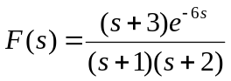
(b) 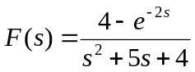
(c) 